

## VISVESVARAYA TECHNOLOGICAL UNIVERSITY BELAGAVI-590 018, KARNATAKA

**UID ASSIGNMENT REPORT ON**

**“BUSINESS UID”**

*Submitted in the partial fulfilment of the requirements for the award of the Degree*

## B.E. in Computer Science & Engineering SUBMITTED BY

#### GAURAV SONI 4BD17CS043

**VIVEK GUPTA 4BD17CS117**

**SUBMITTED TO**

**Dr. Roopa G M M.Tech.,Ph.D., Associate Professor, Department of CS&E,**

**B.I.E.T, Davangere.**

## Department of Computer Science & Engineering

**Bapuji Institute of Engineering & Technology, Davangere-577004 2020-2021**

### Bapuji Educational Association (Regd.)

Bapuji Institute of Engineering and Technology, Davangere – 04 Department of Computer Science & Engineering

**VISION**

To be a center-of-excellence by imbibing state-of-the-art technology in the field of Computer Science and Engineering, thereby enabling students to excel professionally and be ethical.

## MISSION

|  |  |
| --- | --- |
| M1 | Adapting best teaching and learning techniques that cultivates Questioning and Reasoning culture among the students. |
| M2 | Creating collaborative learning environment that ignites the critical thinking in students and leading to the innovation. |
| M3 | Establishing Industry Institute relationship to bridge the skill gap and make them industry ready and relevant. |
| M4 | Mentoring students to be socially responsible by inculcating ethical and moral values. |

**PROGRAM EDUCATIONAL OBJECTIVES (PEOs)**

|  |  |
| --- | --- |
| PEO1 | To apply skills acquired in the discipline of Computer Science and Engineering for solving societal and industrial problems with apt technology intervention. |
| PEO2 | To continue their career in industry/academia or to pursue higher studies and research. |
| PEO3 | To become successful entrepreneurs, innovators to design and develop software products and services that meets the societal, technical and business challenges. |
| PEO4 | To work in the diversified environment by acquiring leadership qualities with effective communication skills accompanied by professional and ethical values. |

**PROGRAM SPECIFIC OUTCOMES (PSOs)**

|  |  |
| --- | --- |
| PSO1 | Analyze and develop solutions for problems that are complex in nature by applying the knowledge acquired from the core subjects of this program. |
| PSO2 | To develop Secure, Scalable, Resilient and distributed applications for industry and societal requirements. |
| PSO3 | To learn and apply the concepts and construct of emerging technologies like Artificial Intelligence, Machine learning, Deep learning, Big Data Analytics, IoT, Cloud Computing, etc for any real time problems. |

**ABSTRACT**

Many business applications have usability problems that reduce employees’ effectiveness and performance. In this assignment, important user interface designs are presented based on the four main interested parties involved in business information systems – End-users, Developers, Software Company Owners/CEOs and Business Owners. Results from several usability test sessions with the above mentioned target groups are gathered and summarized. Adaptive and context-aware user interfaces are presented as a possible solution for most of the problems. As model-driven development emerged as a leading approach for enabling rapid, collaborative development and building adaptive UIs, four generation of model-based user interface development systems, architectures and frameworks are briefly reviewed in this assignment.

# CHAPTER 1

**INTRODUCTION**

**User Interface Design:**

User Interface Design is the craft and process of designing what a user interacts with when communicating with software. **User interface design** is surprisingly hard to define. The crowdsourced definition seems to essentially say "user interface design is the design of software user interfaces," which isn't very enlightening. The work of a user experience (UX) professional is to better understand a user’s ―journey‖ when interacting with a site or piece of software. They want to understand what information users find most important, where they’d expect to find it, how they’d get to it, how they’d interact with it, and more. Additionally, they seek out user information for pain points or areas that make the overall experience clunky or less-than-ideal. Once gathered, they provide recommendations for improvement.

User interface design requires a good understanding of user needs. It mainly focuses on the needs of the platform and its user expectations. There are several phases and processes in the user interface design, some of which are more demanded upon than others, depending on the project.

* Functionality requirements gathering – assembling a list of the functionality required by the system to accomplish the goals of the project and the potential needs of the users.
* [User](https://en.wikipedia.org/wiki/User_analysis) and [task analysis](https://en.wikipedia.org/wiki/Task_analysis) – a form of [field research](https://en.wikipedia.org/w/index.php?title=Field_research_private&action=edit&redlink=1), it's the analysis of the potential users of the system by studying how they perform the tasks that the design must support, and conducting interviews to elaborate their goals. Typical questions involve:
  + What would the user want the system to do?
  + How would the system fit in with the user's normal [workflow](https://en.wikipedia.org/w/index.php?title=Workflow_strictly_private&action=edit&redlink=1) or daily activities?
  + How technically savvy is the user and what similar systems does the user already use?
  + What interface look & feel styles appeal to the user?
* [Information architecture](https://en.wikipedia.org/wiki/Information_architecture) – development of the process and/or information flow of the system (i.e. for phone tree systems, this would be an option tree flowchart and for websites, this would be a site flow that shows the hierarchy of the pages).
* Prototyping – development [of wire-frames,](https://en.wikipedia.org/wiki/Website_wireframe) either in the form of [paper prototypes](https://en.wikipedia.org/wiki/Paper_prototypes) or simple interactive screens. These prototypes are stripped of all look & feel elements and most content to concentrate on the interface.
* [Usability inspection](https://en.wikipedia.org/w/index.php?title=Usability_inspection_private&action=edit&redlink=1) – letting an evaluator inspect a user interface. This is generally considered to be cheaper to implement than usability testing (see step below) and can be used early on in the development process since it can be used to evaluate prototypes or specifications for the system, which usually cannot be tested on users. Some common usability inspection methods include a [cognitive walkthrough,](https://en.wikipedia.org/wiki/Cognitive_walkthrough) which focuses the simplicity to accomplish tasks with the system for new users, [heuristic evaluation,](https://en.wikipedia.org/wiki/Heuristic_evaluation) in which a set of heuristics are used to identify usability problems in the UI design, and [pluralistic walkthrough,](https://en.wikipedia.org/wiki/Pluralistic_walkthrough) in which a selected group of people step through a task scenario and discuss usability issues.
* [Usability testing](https://en.wikipedia.org/wiki/Usability_testing) – testing of the prototypes on an actual user—often using a technique called [think aloud protocol](https://en.wikipedia.org/wiki/Think_aloud_protocol) where you ask the user to talk about their thoughts during the experience. User interface design testing allows the designer to understand the reception of the design from the viewer's standpoint, and thus facilitates creating successful applications.
* Graphical user interface design – actua[l look and feel](https://en.wikipedia.org/wiki/Look_and_feel) the design of the final [graphical user interface](https://en.wikipedia.org/wiki/Graphical_user_interface) (GUI). These are design’s control panels and faces; voice-controlled interfaces involve oral-auditory interaction, while gesture-based interfaces witness users engaging with 3D design spaces via bodily motions. It may be based on the findings developed during the user research and refined to fix any usability problems found through the results of testing. Depending on the type of interface being created, this process typically involves some computer programming to validate forms, establish links or perform a desired action.
* [Software maintenance](https://en.wikipedia.org/wiki/Software_maintenance) – after the deployment of a new interface, occasional maintenance may be required to fix [software bugs,](https://en.wikipedia.org/wiki/Software_bug) change features, or completely upgrade the system. Once a decision is made to upgrade the interface, the [legacy system](https://en.wikipedia.org/wiki/Legacy_system) will undergo another version of the design process and will begin to repeat the stages of the interface life cycle.

# UI and UX:

# The UI is often talked about in conjunction with user experience (UX), which may include the aesthetic appearance of the device, response time and the content that is presented to the user within the context of the user interface. Both terms fall under the concept of human-computer interaction (HCI), which is the field of study focusing on the creation of computer technology and the interaction between humans and all forms of IT design. Specifically, HCI studies areas such as UCD, UI design and UX design.

# An increasing focus on creating an optimized user experience has led some to carve out careers as UI and UX experts. Certain languages, such as HTML and CSS, have been geared toward making it easier to create a strong user interface and experience.

# History of UI:

# In early computers, there was very little user interface except for a few buttons at an operator's console. Many of these early computers used punched cards, prepared using keypunch machines, as the primary method of input for computer programs and data. While punched cards have been essentially obsolete in computing since 2012, some voting machines still use a punched card system.

# The user interface evolved with the introduction of the command line interface, which first appeared as a nearly blank display screen with a line for user input. Users relied on a keyboard and a set of commands to navigate exchanges of information with the computer. This command line interface led to one in which menus (lists of choices written in text) predominated.

# Finally, the GUI arrived, originating mainly in Xerox's Palo Alto Research Center (PARC), adopted and enhanced by Apple and effectively standardized by Microsoft in its Windows operating systems. Elements of a GUI include such things as windows, pull-down menus, buttons, scroll bars and icons. With the increasing use of multimedia as part of the GUI, sound, voice, motion video and virtual reality are increasingly becoming the GUI for many applications.

# The emerging popularity of mobile applications has also affected UI, leading to something called mobile UI. Mobile UI is specifically concerned with creating usable, interactive interfaces on the smaller screens of smartphones and tablets and improving special features, like touch controls.

# User Interface Design Using HTML, CSS AND JAVASCRIPT:

Web technology refers to how computers communicate with each other using markup languages and multimedia packages. It gives us a way to interact with hosted information, like websites. Web technology involves the use of hypertext markup language (HTML) and cascading style sheets (CSS). To make websites look and function a certain way, web developers utilize different languages. The three core languages that make up the World Wide Web are HTML5, CSS, and JavaScript. In the IT world, the internet is an essential platform, whether it's for development or consumer use. When developing a website, typically three main languages come into play. These languages are JavaScript, CSS, and HTML. HTML is the backbone of most web pages. Essentially, it is used to create the structure of how a specific website would look, from the headings to the paragraphs, the body, links, and even images. Markup languages are the languages in which the web is written.

#### HTML:

HTML is a language for describing web pages. HTML stands for HyperText Markup Language. HTML is a markup language. A markup language is a set of markup tags. The tags describe document content. HTML documents contain HTML tags and plain text. HTML documents are also called web pages HTML Tags: HTML markup tags are usually called HTML tags.HTML tags are keywords (tag names) surrounded by angle brackets. HTML tags normally come in pairs like and. The first tag in a pair is the start tag, the second tag is the end tag. The end tag is written like the start tag, with a forward slash before the tag name. Start and end tags are also called opening tags and closing tags content.

#### CSS:

CSS stands for Cascading Style Sheets. Styles define how to display HTML elements. Styles were added to HTML 4.0 to solve a problem. External Style Sheets can save a lot of work. External Style Sheets are stored in CSS files CSS Syntax: A CSS rule has two main parts: a selector, and one or more declarations. The selector is normally the HTML element you want to style. Each declaration consists of a property and a value. The property is the style attribute you want to change. Each property has a value.

# 

# CHAPTER 2

**DESIGN**

Fig: User Interface Design for Business Website

## Description:

The user interface design for the business website has the following parts:

* The home page of the website consists of a business logo, navbar and a carousel with text followed by other content containing overview of website services, client testimonials and a footer.
* The about page has the information about the company, its goals, objectives and team details. The page is divided into two grids. The side panel consists of latest news of the business.
* The services page contains the details about all the services provided by the company.
* The portfolio page consists of samples of work done by the company generally in photo grid format with filter options to narrow down the work samples.
* Pages menu is a dropdown menu which can have multiple subpages belonging to the same group.
* Contact page has the information to reach out to the company. It consists of a form where user has to submit common user details and a message to the company.

# CHAPTER 3

**SNAPSHOTS**

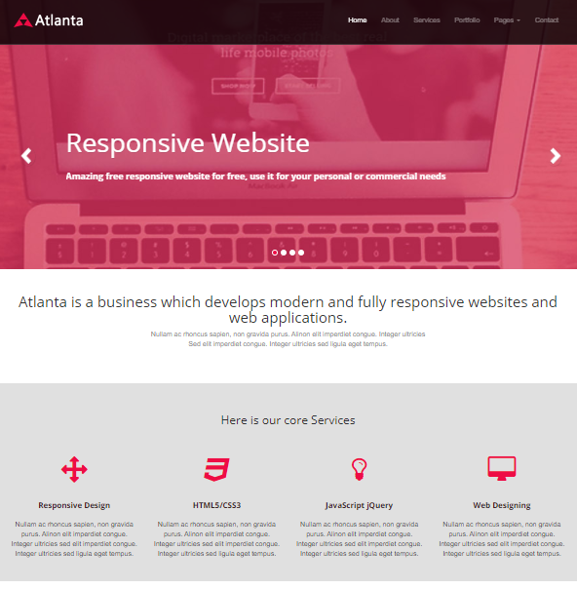

### **Fig:** Home Page - This is the landing page of the business website.

### 

### **Fig:** About Page – This page has the information about the company.

### 

### **Fig:** Services Page – This page contains information about services offered by the company.

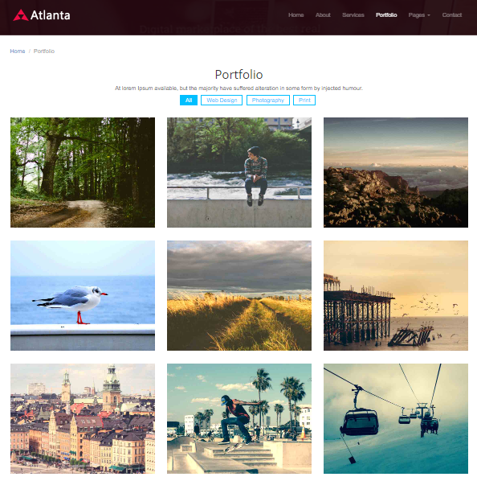

### **Fig:** Portfolio Page – This page consists of previous work done by the company illustrated in photo grid format.

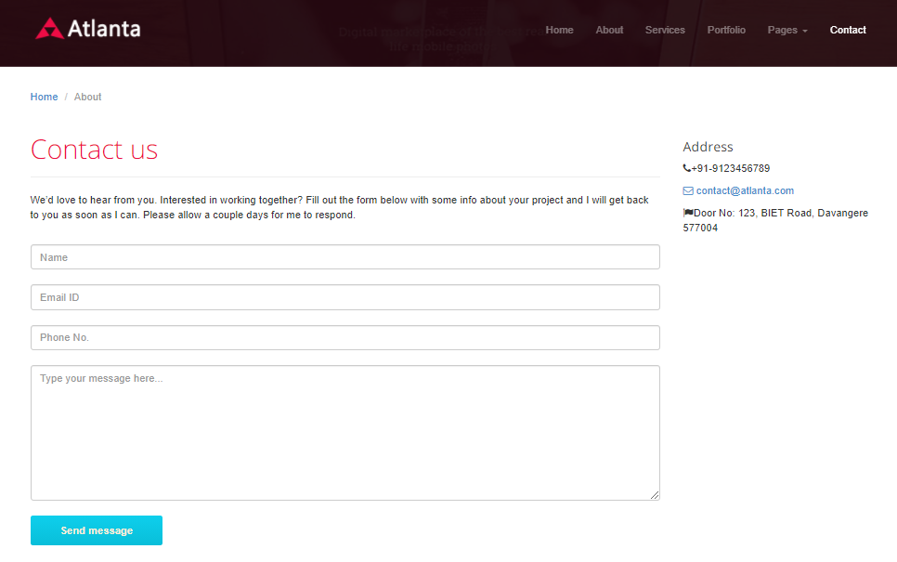

### **Fig:** Contact Page – This page has contact info about the company along with a form which has to be submitted with user details and a message to the company.

**CONCLUSION**

From this Assignment, we came to know how to design a user interface and what are all the basic requirements to design a simple interface. During this assignment, we came across many new things like how to use proper icons for menus and how to host simple design in Github, and many more concepts of HTML, CSS, and JavaScript. In today’s world, where everyone is moving to some or other place, it is priority and privilege to be able to note the experiences. An application where user can read about other’s experiences with the images being posted could be a great pitch if the design is appropriate. Thus such a design could be used by organizations or businesses to offer their services digitally to the world with a smooth user interface and user experience increasing the capital gains of the business and hence leading to its growth.

# DESIGN IS PUBLISHED AND COULD BE VIEWED ON:

<https://ergauravsoni.github.io/Assignment-UID/index.html>